Which Academic Assessments Cause Anxiety in UTAS Students?

Computer and Information Systems Department,
University of Technology and Applied Sciences, Muscat, Oman

Abstract— This study examines academic anxiety among students at the University of Technology and Applied Sciences (UTAS) in Muscat, Oman, focusing on which assessment types induce the highest anxiety and how this affects academic performance and well-being. Using a correlational research design, data were collected from 101 students across multiple departments via a structured online questionnaire. Analyses included descriptive statistics, one-sample t-tests, correlation, and multiple regression to examine relationships between assessment types, internal academic concerns, and overall anxiety. Results indicate that examinations and presentations generated the highest anxiety, while assignments caused the least. Key predictors of anxiety were fear of mistakes, grade pressure, and performance concerns; demographic factors had minimal influence. Students employed coping strategies such as time management, peer support, and practice-based preparation. These findings provide evidence for the Cognitive Appraisal framework, highlighting the importance of student-centered assessment design and targeted support strategies to mitigate anxiety and enhance academic performance and psychological well-being in Omani higher education.

Keywords— academic anxiety, assessment types, student well-being, cognitive appraisal theory, higher education, Oman.
- Introduction
Academic environments foster learning, skill development, and personal growth, yet they also expose students to considerable psychological pressure. In higher education, assessments such as examinations, presentations, projects, quizzes, and assignments often contribute to increased anxiety, influencing concentration, motivation, and academic performance. As mental well-being becomes central to student success, institutions face growing concern regarding the emotional burden associated with academic assessment.
At the University of Technology and Applied Sciences (UTAS), Muscat, students frequently report high anxiety during high-stakes assessments. However, limited empirical evidence identifies which assessment types cause the strongest anxiety reactions or what underlying elements contribute to these emotional responses. Factors such as time constraints, grading intensity, and unfamiliar assessment formats may increase anxiety but remain underexplored within this context.
This study examines assessment-related anxiety among UTAS students by evaluating its intensity across various academic tasks and exploring how such anxiety influences performance and self-perceived well-being. Through survey-based analysis, the research identifies major anxiety triggers and highlights student coping mechanisms. The study contributes by determining which assessment types induce the highest anxiety, identifying assessment-related elements that contribute most to anxiety, and offering practical recommendations for improving assessment practices.
- Literature Review
  - Influence of Assessment Type on Academic Anxiety
- Impact of Assessment Format on Anxiety Responses:
Mirawdali examined how written, oral, and practical assessments influence anxiety among pharmacy undergraduates. Oral and practical assessments, particularly OSCEs, elicited the highest anxiety due to communication pressure and public evaluation, while written exams induced anxiety related to workload and time limits. Although insightful, the study's self-reported data and discipline-specific sample limit generalizability[1].
- Formative vs. Summative Assessment and Emotional:
Ismail compared formative and summative assessments among Iranian EFL learners. Formative assessments significantly reduced test anxiety and improved motivation, emphasizing the role of feedback. However, the small sample and short intervention period limited the broader applicability of findings[2].
  - Relationship Between Test Anxiety and Academic Performance
- Cognitive and Emotional Dimensions of Test Anxiety:
Rana and Mahmood found a strong negative relationship between test anxiety and academic achievement. Cognitive worry emerged as the strongest predictor of low performance, highlighting how intrusive thoughts impair working-memory efficiency[3].
- Self-Efficacy, Fear of Evaluation, and Anxiety:
Hull reported that higher self-efficacy correlates with lower anxiety, whereas open-ended or public assessments, such as presentations, generate higher anxiety. Small sample size and limited standardized measures reduced reliability[4].
- Longitudinal Patterns of Statistics Anxiety:
Frias Navarro observed that the subject of statistics, which causes anxiety to students, decreased over the semester as students gained familiarity with coursework. Anxiety still negatively correlated with performance, underscoring the importance of preparation and instructional clarity[5].
  - Academic Anxiety in Broader Mental Health Contexts
- Socioeconomic and Institutional Predictors of Anxiety:
Al Husaini and Shukor identified several non-academic factors financial strain, inadequate housing, family support deficits, and gender influences, that contribute to academic anxiety. The absence of mental health measurement tools limits deeper psychological interpretation[6].
- Academic Pressure and Psychological Health Using Mixed Methods:
Rabbi and Islam’s mixed-methods study showed that high academic anxiety predicts reduced motivation and poorer psychological health. Qualitative insights added depth but were constrained by single-site sampling[7].
- Post-Pandemic Academic Anxiety and Emotional Health:
Meng Chuan highlighted anxiety spikes among students transitioning back to campus post-pandemic, driven by increased workloads and fear of failure. Despite strong instrumentation, the small sample size limited broader application[8].
  - Coping Mechanisms and Support Systems for Anxiety Reduction
- Technological Interventions for Anxiety Reduction:
Elbourhamy found that automated exam evaluation systems reduced student anxiety by ensuring fairness and grading consistency. The study lacked long-term follow-up but demonstrated the potential of technology-based interventions[9].

- Standardization of Test Anxiety Measurement for Support Programs:
Cassady conducted a systematic review to categorize and evaluate existing methods for measuring test anxiety. The review revealed that up to 80% of university students experience moderate to severe test anxiety, but unreliable measurement techniques impede effective intervention efforts. The review provides a methodological foundation for developing standardized, psychometrically sound assessment tools essential for academic support systems[10].
- Research Models and Methods
This study employs a correlational research model to investigate the relationships between assessment types and anxiety levels among UTAS students. No variables were manipulated; instead, naturally occurring differences among student experiences were analyzed.
Data were collected through a structured online questionnaire distributed via Microsoft Forms. The instrument included multiple-choice items, Likert-scale measures, and short-answer questions addressing anxiety, assessment experiences, coping strategies, and demographic information. A pilot test ensured clarity and reliability.
Convenience sampling was used to gather responses from four departments: Computer and Information Systems, Engineering, Business, and Applied Sciences. The final sample consisted of 101 undergraduate students.
Data analysis employed descriptive statistics, independent samples t-tests, correlation analysis, and multiple regression to identify key predictors of anxiety. Qualitative responses were analysed thematically. Ethical procedures ensured confidentiality, anonymity, informed consent, and secure data storage.
- Data analysis
A total of 101 students from multiple UTAS departments participated in the study.
TABLE I
Demographic distribution of participants
Category | Subcategory /Item | Frequency | Percentage (%)
Gender | Female | 76 | 75.25
 | Male | 25 | 24.75
Age | 18–22 | 72 | 71.29
 | 23–26 | 28 | 27.72
 | 27-above | 1 | 0.99
Study | Computer and Information Systems | 64 | 63.37
 | Engineering | 24 | 23.76
 | Business | 7 | 6.93
 | Applied Science | 5 | 4.95
 | Business | 1 | 0.99
Level | 1st or 2nd year Diploma | 25 | 24.75
 | Advanced Diploma | 49 | 48.51
 | Bachelor | 27 | 26.73

Descriptive statistics summarized participants' demographic data. It presents frequencies and percentages for gender, age, study program, and academic level. The majority of respondents were female (75.25%) and aged 18–22 years (71.29%).
TABLE II
Distribution of Participants’ Assessment Performance Based on Likert and Overall Scores

Assessment Type | Likert % | Overall % | Combined %
Examination | 81.18 | 38.12 | 59.65
Presentation | 81.98 | 29.76 | 55.87
Project | 72.67 | 14.36 | 43.51
Quiz | 70.69 | 13.36 | 42.02
Assignment | 63.56 | 4.45 | 34.00

Measures of central tendency showed that examinations and presentations elicited the highest mean anxiety scores, whereas assignments generated the lowest anxiety. The combined anxiety metric, integrating Likert means and selection percentages, confirmed that examinations were the most anxiety-inducing assessments.

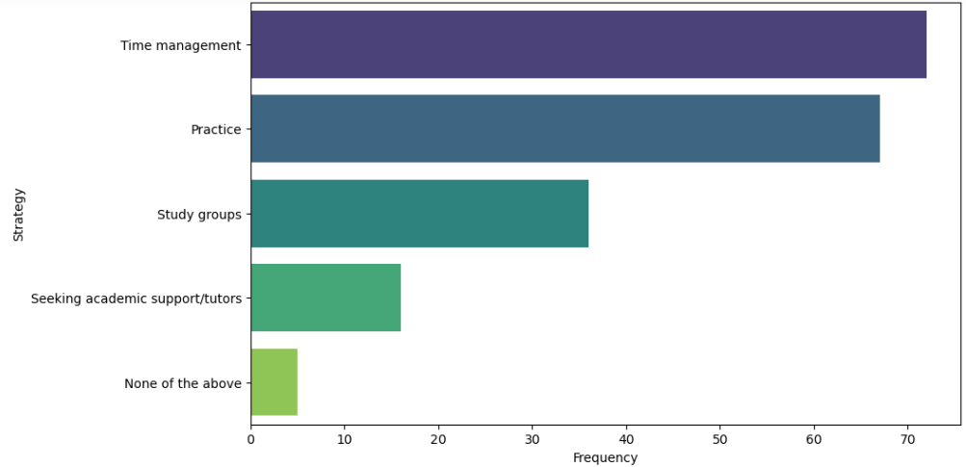
Fig. 1 Coping Strategies

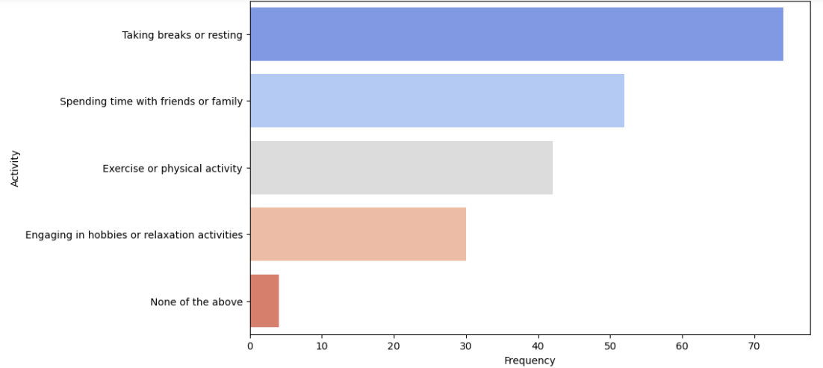
Fig. 2 Activities Improving Well-Being

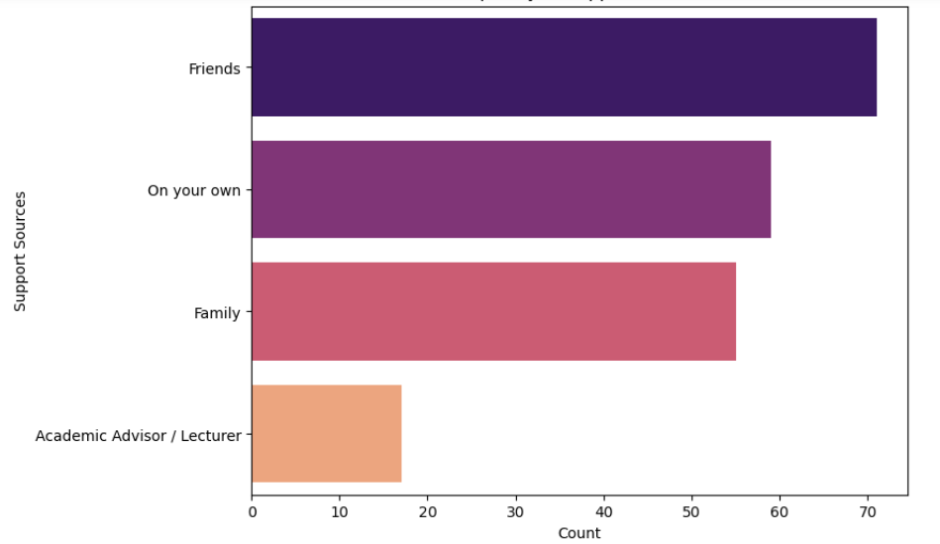
Fig. 3 Support Sources

Students reported a variety of coping strategies, including time management, practice, and peer support. Primary sources of support included friends, family, and self-guided strategies. Activities enhancing well-being during assessment periods included breaks, social interactions, exercise, and hobbies.
For the Inferential statistics, one-sample t-tests were conducted to compare mean anxiety levels against the neutral midpoint value of 3.
Hypothesis 1
H0.1: There is no difference in anxiety levels in UTAS students across different assessments.
H1.1: There is a difference in anxiety levels in UTAS students across different assessments.
Hypothesis 2
H0.2: Elements such as time pressure, grading weight, and unfamiliar formats do not significantly contribute to assessment-related anxiety.
H1.2: Elements such as time pressure, grading weight, and unfamiliar formats significantly contribute to assessment-related anxiety.
TABLE III
One-Sample T-Test Results of Participants' Assessment Performance
Assessment | Mean Score | T-Statistic | P-Value | Interpretation
Examination | 4.06 | 11.505 | 0.000 | Mean > Neutral → Reject H₀
Presentation | 4.10 | 11.331 | 0.000 | Mean > Neutral → Reject H₀
Quizzes | 3.53 | 5.097 | 0.000 | Mean > Neutral → Reject H₀
Project | 3.63 | 5.597 | 0.000 | Mean > Neutral → Reject H₀
Assignment | 3.18 | 1.702 | 0.092 | Mean ≈ Neutral → Fail to Reject H₀

The results indicate that examinations, presentations, quizzes, and projects produced mean anxiety scores significantly higher than the neutral midpoint (p < 0.05), suggesting that these assessments contribute to elevated anxiety levels among UTAS students. In contrast, assignments did not differ significantly from the neutral value (p = 0.092), indicating a negligible effect on student anxiety. These findings lead to the rejection of H0.1, thereby supporting Hypothesis 1, which states that anxiety levels vary across assessment types. Regarding Hypothesis 2, most assessment elements, such as time pressure, grading weight, and unfamiliar formats, significantly contributed to anxiety, except assignments, which showed no significant effect. Consequently, H0.2 is largely rejected, and Hypothesis 2 is generally supported.
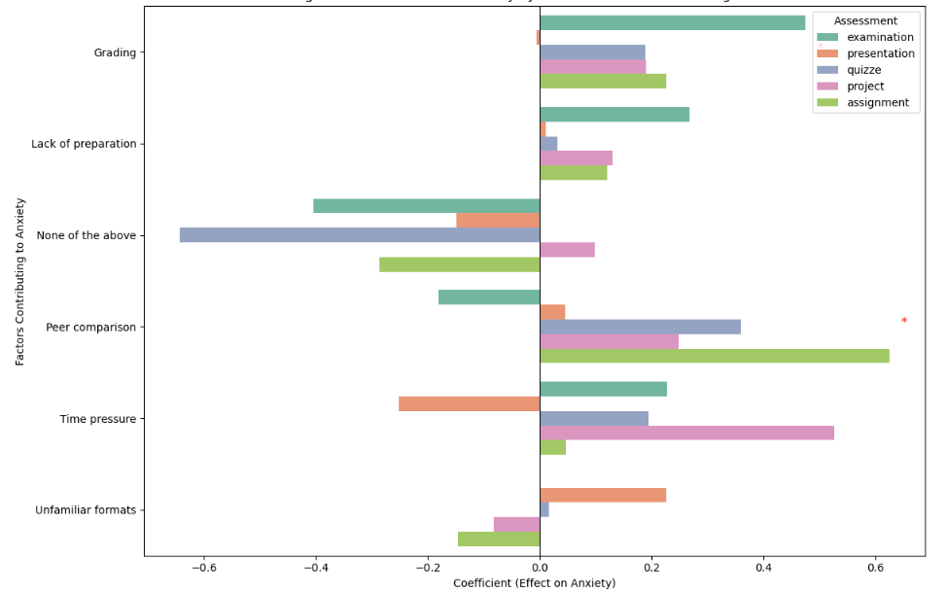
Fig. 4 Regression Coefficients for Anxiety by Assessment and Contributing Factors
A multiple linear regression analysis was performed to identify factors influencing student anxiety. Results indicated that grading pressure, fear of mistakes, and peer comparison were significant predictors across assessment types.

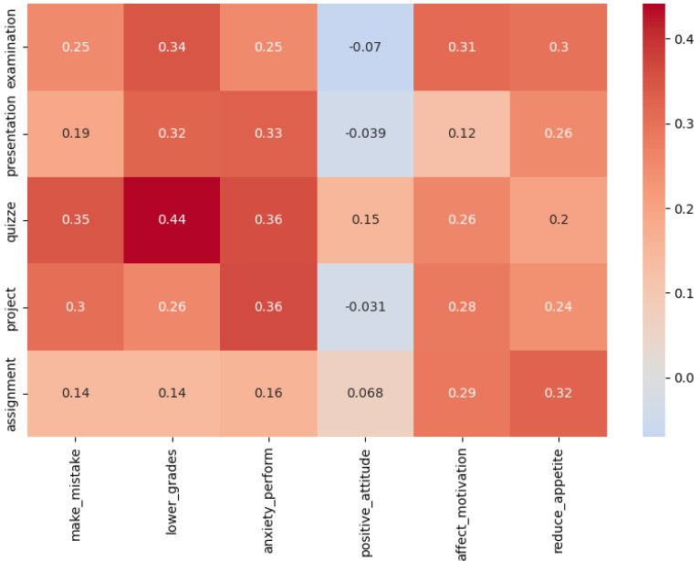
Fig. 5 Correlation between Student Anxiety Assessments and Well-Being Factors

Correlation analysis showed moderate positive correlations between fear of making mistakes, concern over lower grades, and anxiety across assessments, indicating that these personal academic concerns are strongly linked to higher assessment anxiety. In contrast, positive attitudes and motivation-related factors showed weaker or slightly negative correlations, suggesting that supportive cognitive and emotional traits may help reduce assessment anxiety.
- Discussion
The findings demonstrate that assessment formats requiring real-time performance, such as examinations and presentations, heighten anxiety more than flexible tasks like assignments. This pattern aligns with literature emphasizing the role of time pressure, public evaluation, and high grading in amplifying anxiety.
Importantly, the results highlight that internal academic concerns such as fear of mistakes, grade pressure, and comparison with peers serve as stronger predictors of anxiety than demographic or structural factors. These insights reinforce the Cognitive Appraisal framework, indicating that students' perceived ability to manage assessment demands significantly influences their emotional response.
The study also reveals that students rely heavily on self-directed coping mechanisms such as time management, practice, and peer support. These strategies, while helpful, indicate a need for institutional interventions such as assessment redesign, anxiety management workshops, and supportive academic policies.
- Conclusions
This study examined the impact of academic assessments on anxiety levels among UTAS students and their influence on academic performance and well-being. The findings indicate that examinations and presentations elicited the highest anxiety, while projects and quizzes caused moderate anxiety, and assignments produced the least. Internal academic concerns, including fear of mistakes, grade pressure, and performance anxiety, were the strongest predictors of overall anxiety, supporting Cognitive Appraisal Theory. The results underscore the importance of student-centered assessment design and targeted support strategies in mitigating anxiety, enhancing performance, and promoting psychological well-being. Although the study was limited to a single campus and relied on self-reported data, it provides valuable evidence that academic anxiety is a significant concern at UTAS. Future research should explore longitudinal patterns, intervention strategies, and comparative analyses across multiple campuses to further inform evidence-based practices that promote student success and well-being [11].
Acknowledgment
The authors would like to express their sincere appreciation to the University of Technology and Applied Sciences (UTAS), Muscat, for providing the institutional support necessary for the successful completion of this research. The authors also extend their gratitude to their supervisor for her guidance, valuable feedback, and continuous encouragement throughout the study. Finally, the authors wish to thank the participating UTAS students whose cooperation and insights were essential to the data collection process and overall contribution to this work.
References

[1] S. Mirawdali, H. Morrissey, and P. Ball, “ACADEMIC ANXIETY AND ITS EFFECTS ON ACADEMIC PERFORMANCE,” 2018.
[2] S. M. Ismail, D. R. Rahul, I. Patra, and E. Rezvani, “Formative vs. summative assessment: impacts on academic motivation, attitude toward learning, test anxiety, and self-regulation skill,” Lang. Test. Asia, vol. 12, no. 1, p. 40, Sept. 2022, doi: 10.1186/s40468-022-00191-4.
[3] R. A. Rana and N. Mahmood, “RELATIONSHIP BETWEEN TEST ANXIETY AND ACADEMIC ACHIEVEMENT”.
[4] K. Hull et al., “Student Anxiety and Evaluation,” Collect. Essays Learn. Teach., vol. 12, pp. 23–35, June 2019, doi: 10.22329/celt.v12i0.5409.
[5] D. Frias-Navarro et al., “Statistics anxiety in university students in assessment situations,” in Proceedings of the 4th International Conference on Higher Education Advances (HEAd’18), Universitat Politècnica València, June 2018, pp. 1–8. doi: 10.4995/HEAD18.2018.7990.
[6] Y. Al Husaini and N. Shukor, “(PDF) Factors Affecting Students’ Academic Performance: A review.” Accessed: Sept. 23, 2025. [Online]. Available: https://www.researchgate.net/publication/367360842_Factors_Affecting_Students'_Academic_Performance_A_review
[7] Md. Fajlay Rabbi and Md. Sefatul Islam, “The Effect of Academic Stress and Mental Anxiety among the Students of Khulna University,” Edukasiana J. Inov. Pendidik., vol. 3, no. 3, pp. 280–299, June 2024, doi: 10.56916/ejip.v3i3.723.
[8] H. Meng Chuan, L. Chye Ying, P. Khong Yun, O. Pei Boon, and K. Kay Hooi, “ACADEMIC STRESS AND ANXIETY AMONG UNDERGRADUATE STUDENTS IN MALAYSIA,” Int. J. Educ. Psychol. Couns., vol. 7, no. 46, pp. 98–109, June 2022, doi: 10.35631/IJEPC.746009.
[9] D. M. Elbourhamy, “Automated evaluation systems to enhance exam quality and reduce test anxiety,” PeerJ Comput. Sci., vol. 11, p. e2666, Feb. 2025, doi: 10.7717/peerj-cs.2666.
[10] J. C. Cassady, S. H. Tan, A. Robiullah, I. Badzovski, and J. Janiuk, “Methods Employed in Studies Identifying ‘Levels’ of Test Anxiety in University Students: A Systematic Review,” Behav. Sci., vol. 15, no. 3, p. 331, Mar. 2025, doi: 10.3390/bs15030331.
[11] “Summary of Lazarus and Folkman’s Theory of stress, appraisal, and coping - Jokogunawan.com.” Accessed: Dec. 05, 2025. [Online]. Available: https://jokogunawan.com/summary-of-lazarus-and-folkmans-theory-of-stress-appraisal-and-coping/

